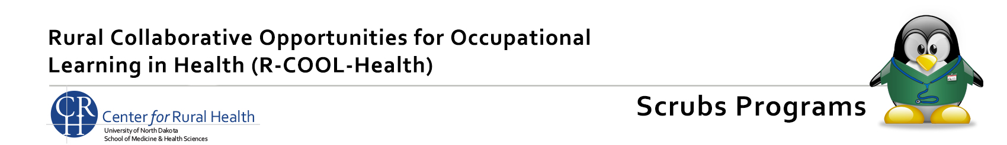

Why collect student and parent contact information?

The Center for Rural Health (CRH) requests contact information for all students and parents participating in a Scrubs Camp. CRH staff realizes this information may change, but this is our best opportunity to get contact information so we may connect with participants in the future.

There are a couple different reasons why the CRH may contact students or parents. We may want to share scholarship or educational opportunities or find out if participating in a healthcare activity, such as a Scrubs Camp, positively impacted a student’s decision to pursue a career in healthcare. This allows the CRH to justify whether or not the funding of these and similar programs should continue.

Any contact information shared will be kept confidential within the CRH and used only for workforce related purposes. The information will NOT be shared or sold to any other entity.

If you choose to not share this information, we certainly understand. This will not impact your child’s opportunity to participate in a Scrubs Camp. We thank you for supporting our efforts to encourage careers in healthcare in North Dakota.

