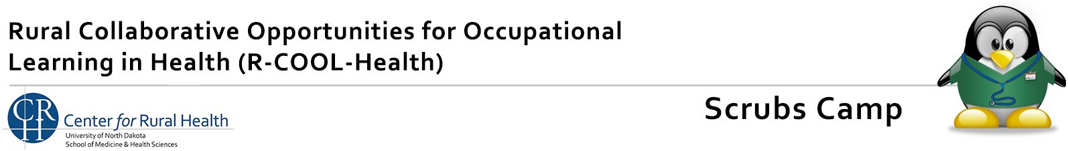

SPEAKER Q&A

# WHAT IS SCRUBS CAMP?

Scrubs Camps are one-day, hands-on health career exploration opportunities for 5th grade through 12th grade students. Students will learn about the wide variety of health careers that are available to them through lecture, hands-on activities, and discussion.

The Scrubs Camp is a day-long event where students will hear from a variety of healthcare professionals who will discuss what they do and how they got into their professions. Students will also have a chance to experience many hands-on activities throughout the day. Scrubs Camp is aimed at for 5th grade through 12th grade students who have an interest in entering the healthcare field.

# WHAT WILL THE DAY BE LIKE?

Over the course of the day, students will hear from approximately 8-10 healthcare speakers, do many hands-on healthcare career-related activities and learn more about educational opportunities in North Dakota’s high schools. Students will have lunch on site and also be allowed time to complete their HIPAA certification and sign-up to job shadow. Camps will run approximately 8:00 am - 3:30 pm.

# WHAT DO WE NEED FROM YOU AS A SPEAKER?

Plan to devote 1/4th of your total session time to discussing your career. The remaining time should be devoted to a hands-on activity that is pertinent to your occupation. For ideas and examples of hands-on activities, contact Nicole Threadgold at 701-330-3264 or nicole[.threadgold@UND.edu.](mailto:Brittany.Dryburgh@UND.edu)

# WHAT SHOULD I TALK ABOUT?

* What is your job/formal job title/where do you work
* What made you choose that career
* Where did you go to school/train and how long did it take
* What do you do/what is a typical day like for you
* What do you like best about your job
* What classes should students take in high school and in postsecondary programs/Volunteer Experience/Part-time jobs
* Work Environment: alone/group, office/open area, sitting/on feet, etc.

If you need assistance in hands-on presentation ideas, please contact Nicole Threadgold at 701-330-3264 [or](mailto:Brittany.Dryburgh@UND.edu) nicole[.threadgold@U](mailto:Brittany.Dryburgh@UND.edu)ND.edu.