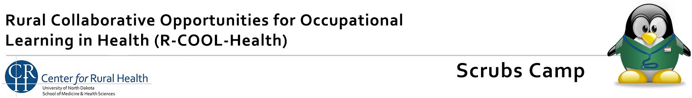

News Release Form

We would like to send a news release to the newspapers and other media sources whose communities will be taking part in the R-COOL-Health Scrubs Camp you are coordinating. Please fill out this form and return it to Nicole Threadgold via e-mail to nicole.threadgold@und.edu.
Your Name:

Organization:

Newspaper(s)/media sources you wish the release to be submitted to:

Name: City:

Name: City:

Name: City:

Name: City:
Name: City:

Additional media outlets:

I grant the Center for Rural Health at The University of North Dakota School of Medicine and Health Sciences permission to publish a news release regarding the recent award received.
Signature:

If you have questions, contact
Nicole Threadgold, Grant Program Director
Center for Rural Health, at 701-330-3264 or nicole.threadgold@und.edu

