
Scrubs Academy II

July 13-16, 2026

Minot, North Dakota

What? R-COOL-Health Scrubs Academy II
When? July 13-16, 2026
Where? Minot, North Dakota (drop off/pick up at Minot State University)
Cost? $ 350 (includes meals, lodging, during-camp transportation, activity fees, shirts, backpack, and more
Why? To learn what healthcare professionals do in FUN and INTERACTIVE ways!
Who? Any North Dakota student who has completed 9th, 10th or 11th grade as of June 2026, space is limited to 15 students.
Scrubs Academy II is a four-day/three-night camp where high school students learn what it is like to be a health professional and see an array of healthcare professions they may consider as a career. Students spend their days in various health facilities (critical access hospitals, tertiaries, clinics, long term care and assisted living facilities, ambulances, treatment centers), enjoy fun activities in the evenings, and spend the night in the Minot State University dorms. Students have the opportunity to job shadow multiple professions during the camp.

For more information, including an application, visit: https://ruralhealth.und.edu/projects/scrubs-program/academy-ii
Deadline to apply: 11:59 pm Central, April 30, 2026.
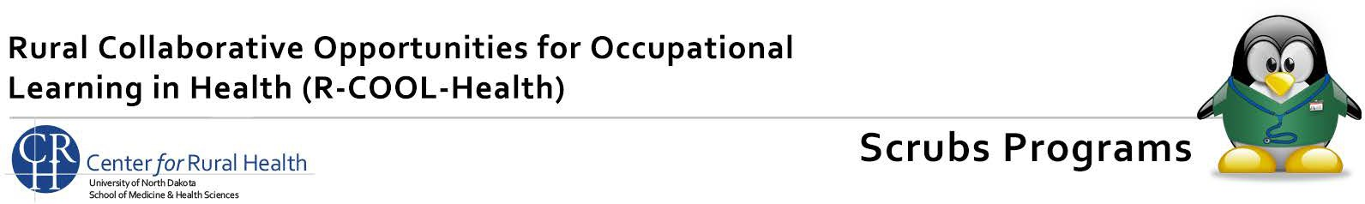
Questions? McKenzi Sapaugh • mckenzi.sapaugh@UND.edu

